INTERNET OF THINGS

Arduino

Arduino is a project, open-source hardware, and software platform used to design and build electronic devices. It designs and manufactures microcontroller kits and single-board interfaces for building electronics projects.

The Arduino boards were initially created to help the students with the non-technical background.

The Arduino board consists of sets of analog and digital I/O (Input / Output) pins, which are further interfaced to **breadboard, expansion boards,** and other **circuits**. Such boards feature the model, Universal Serial Bus (**USB**), and **serial communication interfaces**, which are used for loading programs from the computers.

It also provides an **IDE** (Integrated Development Environment) project, which is based on the Processing Language to upload the code to the physical board.

The projects are authorized under the **GPL** and **LGPL**. The **GPL** is named **as GNU General Public License.** The licensed **LGPL** is named as **GNU Lesser General Public License**. It allows the use of Arduino boards, it's software distribution, and can be manufactured by anyone.

**The  [arduino is used for various purposes](https://www.javatpoint.com/arduino)**

* Finger button
* Button for motor activation
* Light as a sensors
* LED button
* Designing
* The Building of electronic devices

What is Arduino?

Arduino is a software as well as hardware platform that helps in making electronic projects. It is an open source platform and has a variety of controllers and microprocessors. There are various types of Arduino boards used for various purposes.

The Arduino is a single circuit board, which consists of different interfaces or parts. The board consists of the set of digital and analog pins that are used to connect various devices and components, which we want to use for the functioning of the electronic devices.

Most of the Arduino consists of 14 digital I/O pins.

The analog pins in Arduino are mostly useful for fine-grained control. The pins in the Arduino board are arranged in a specific pattern. The other devices on the Arduino board are USB port, small components (voltage regulator or oscillator), microcontroller, power connector, etc.

Microcontroller

The most essential part of the Arduino is the Microcontroller, which is shown below:

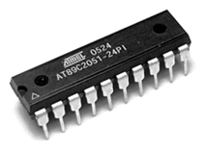

* Microcontroller is small and low power computer. Most of the microcontrollers have a RAM (Random Access Memory), CPU (Central Processing Unit), and a memory storage like other computer systems.
* It has very small memory of 2KB (two Kilobytes). Due to less memory, some microcontrollers are capable of running only one program at a time.
* It is a single chip that includes memory, Input/Output (I/O) peripherals, and a processor.
* The GPIO (General Purpose Input Output) pins present on the chip help us to control other electronics or circuitry from the program.

Arduino Boards

There are variety of Arduino board used for different purposes. The board varies in I/O pins, size, etc. The various components present on the [Arduino boards](https://www.javatpoint.com/arduino-boards)

are Microcontroller, Digital Input/Output pins, USB Interface and Connector, Analog Pins, Reset Button, Power button, LED's, Crystal Oscillator, and Voltage Regulator. Some components may differ depending on the type of board.

Let's discuss some of the popular Arduino boards.

* Arduino UNO
* Arduino Nano
* Arduino Mega
* Arduino Due
* Arduino Bluetooth

Arduino Uno :

* The Arduino Uno is an open-source microcontroller board based on the Microchip ATmega328P microcontroller and developed by Arduino.cc.
* The board is equipped with sets of digital and analog input/output (I/O) pins that may be interfaced to various expansion boards (shields) and other circuits.
* The board has 14 digital I/O pins (six capable of PWM output), 6 analog I/O pins, and is programmable with the Arduino IDE (Integrated Development Environment), via a type B USB cable.
* It can be powered by the USB cable or by an external 9-volt battery, though it accepts voltages between 7 and 20 volts.
* It is similar to the Arduino Nano and Leonardo.
* The hardware reference design is distributed under a Creative Commons Attribution Share-Alike 2.5 license and is available on the Arduino website.
* Layout and production files for some versions of the hardware are also available.

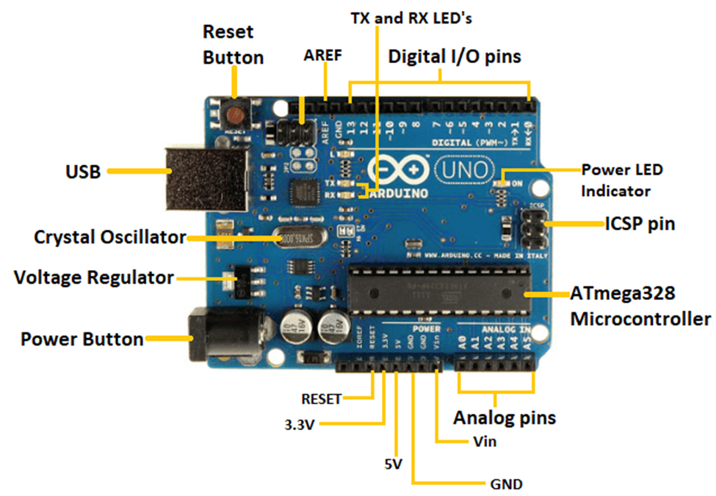

|  |  |
| --- | --- |
| **Arduino Uno Specifications Table** | |
| Microcontroller | ATmega38P – 8 bit AVR family microcontroller |
| Operating Voltage | 5V |
| Recommended Input Voltage | 7-12V |
| Input Voltage Limits | 6-20V |
| Analog Input Pins | 6 (A0-A5) |
| Digital I/O Pins | 14 (Out of which 6 provide PWM output) |
| DC Current on I/O Pins | 40mA |
| DC Current on 3.3V Pin | 50mA |
| Flash Memory | 32 KB (0.5 KB is used for Bootloader) |
| SRAM | 2kB |
| EEPROM | 1kB |
| Frequency (Clock Speed) | 16MHz |

Overview of the Arduino UNO Components:

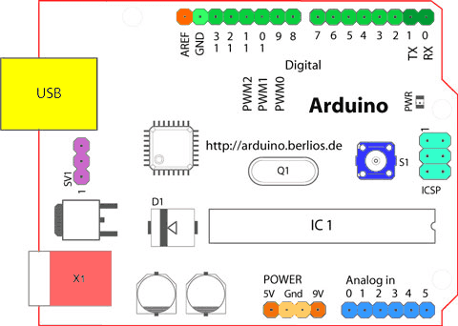

Starting clockwise from the top center:

* Analog Reference pin (orange)
* Digital Ground (light green)
* Digital Pins 2-13 (green)
* Digital Pins 0-1/Serial In/Out - TX/RX (dark green) - These pins cannot be used for digital i/o (digitalRead and digitalWrite) if you are also using serial communication (e.g. Serial.begin).
* Reset Button - S1 (dark blue)
* In-circuit Serial Programmer (blue-green)
* Analog In Pins 0-5 (light blue)
* Power and Ground Pins (power: orange, grounds: light orange)
* External Power Supply In (9-12VDC) - X1 (pink)
* Toggles External Power and USB Power (place jumper on two pins closest to desired supply) - SV1 (purple)
* USB (used for uploading sketches to the board and for serial communication between the board and the computer; can be used to power the board) (yellow)

**Microcontrollers**

[ATmega328P](https://content.arduino.cc/assets/Atmel-7810-Automotive-Microcontrollers-ATmega328P_Datasheet.pdf?) (used on most recent boards)

* Digital I/O Pins: 14 (of which 6 provide PWM output)
* Analog Input Pins: 6 (DIP) or 8 (SMD)
* DC Current per I/O Pin: 40 mA
* Flash Memory: 32 KB
* SRAM: 2 KB
* EEPROM: 1KB

**ATmega168** (used on most Arduino Diecimila and early Duemilanove)

* Digital I/O Pins: 14 (of which 6 provide PWM output)
* Analog Input Pins: 6 (DIP) or 8 (SMD)
* DC Current per I/O Pin: 40 mA
* Flash Memory 16 KB:
* SRAM: 1 KB
* EEPROM: 512 bytes

**ATmega8** (used on some older board)

* Digital I/O Pins: 14 (of which 3 provide PWM output)
* Analog Input Pins: 6
* DC Current per I/O Pin: 40 mA
* Flash Memory: 8 KB
* SRAM: 1 KB
* EEPROM: 512 bytes

**Digital Pins**

In addition to the specific functions listed below, the digital pins on an Arduino board can be used for general purpose input and output via the [pinMode()](https://www.arduino.cc/reference/en/language/functions/digital-io/pinmode/), [digitalRead()](https://www.arduino.cc/reference/en/language/functions/digital-io/digitalread/), and [digitalWrite()](https://www.arduino.cc/reference/en/language/functions/digital-io/digitalwrite/) commands. Each pin has an internal pull-up resistor which can be turned on and off using digitalWrite() (w/ a value of HIGH or LOW, respectively) when the pin is configured as an input. The maximum current per pin is 40 mA.

* Serial: 0 (RX) and 1 (TX). Used to receive (RX) and transmit (TX) TTL serial data. On the Arduino Diecimila, these pins are connected to the corresponding pins of the FTDI USB-to-TTL Serial chip. On the Arduino BT, they are connected to the corresponding pins of the WT11 Bluetooth® module. On the Arduino Mini and LilyPad Arduino, they are intended for use with an external TTL serial module (e.g. the Mini-USB Adapter).
* External Interrupts: 2 and 3. These pins can be configured to trigger an interrupt on a low value, a rising or falling edge, or a change in value. See the [attachInterrupt()](https://www.arduino.cc/reference/en/language/functions/external-interrupts/attachinterrupt/) function for details.
* PWM: 3, 5, 6, 9, 10, and 11. Provide 8-bit PWM output with the [analogWrite()](https://www.arduino.cc/reference/en/language/functions/analog-io/analogwrite/) function. On boards with an ATmega8, PWM output is available only on pins 9, 10, and 11.
* BT Reset: 7. (Arduino BT-only) Connected to the reset line of the Bluetooth® module.
* SPI: 10 (SS), 11 (MOSI), 12 (MISO), 13 (SCK). These pins support SPI communication, which, although provided by the underlying hardware, is not currently included in the Arduino language.
* LED: 13. On the Diecimila and LilyPad, there is a built-in LED connected to digital pin 13. When the pin is HIGH value, the LED is on, when the pin is LOW, it's off.

**Analog Pins**

In addition to the specific functions listed below, the analog input pins support 10-bit analog-to-digital conversion (ADC) using the [analogRead()](https://www.arduino.cc/reference/en/language/functions/analog-io/analogread/) function. Most of the analog inputs can also be used as digital pins: analog input 0 as digital pin 14 through analog input 5 as digital pin 19. Analog inputs 6 and 7 (present on the Mini and BT) cannot be used as digital pins.

* I2C: 4 (SDA) and 5 (SCL). Support I2C (TWI) communication using the [Wire](http://wiring.org.co/reference/libraries/Wire/index.html) library (documentation on the Wiring website).

**Power Pins**

* VIN (sometimes labelled "9V"). The input voltage to the Arduino board when it's using an external power source (as opposed to 5 volts from the USB connection or other regulated power source). You can supply voltage through this pin, or, if supplying voltage via the power jack, access it through this pin. Note that different boards accept different input voltages ranges, please see the documentation for your board. Also note that the LilyPad has no VIN pin and accepts only a regulated input.
* 5V. The regulated power supply used to power the microcontroller and other components on the board. This can come either from VIN via an on-board regulator, or be supplied by USB or another regulated 5V supply.
* 3V3. (Diecimila-only) A 3.3 volt supply generated by the on-board FTDI chip.
* GND. Ground pins.

**Other Pins**

* AREF. Reference voltage for the analog inputs. Used with [analogReference()](https://www.arduino.cc/reference/en/language/functions/analog-io/analogreference/).
* Reset. (Diecimila-only) Bring this line LOW to reset the microcontroller. Typically used to add a reset button to shields which block the one on the board.